Phase 10 – Final Presentation & Demo
Objective
The goal of Phase 10 is to present the completed Salesforce Expense Tracker project to stakeholders, demonstrating all implemented functionalities, workflow, and automation. This phase highlights the usability, automation, reporting, and overall effectiveness of the system.

Scope of the Demo
The demo covers the following key functionalities:
- Expense Submission by Finance Manager
  - Creation of new expense records with fields: Expense Name, Amount, Date, Category, and Submitter Email.
  - Automatic flagging of high-value expenses (Amount > 500) for CEO review.
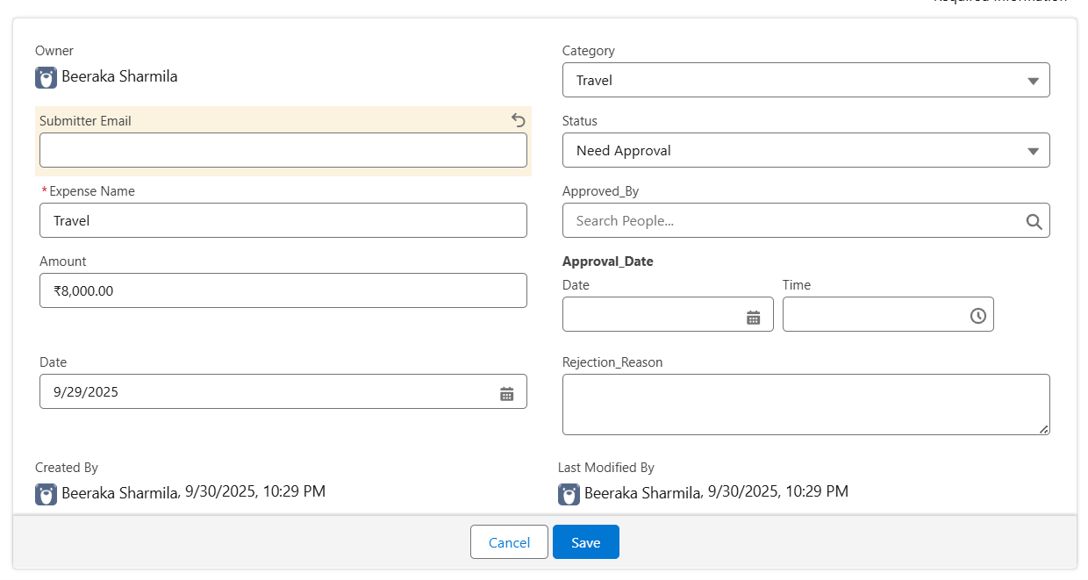
- Expense Approval by CEO
  - CEO reviews high-value expense records.
  - Status can be updated to Approved or Rejected.
  - Fields Approved By, Approval Date, and Rejection Reason are manually entered by CEO.
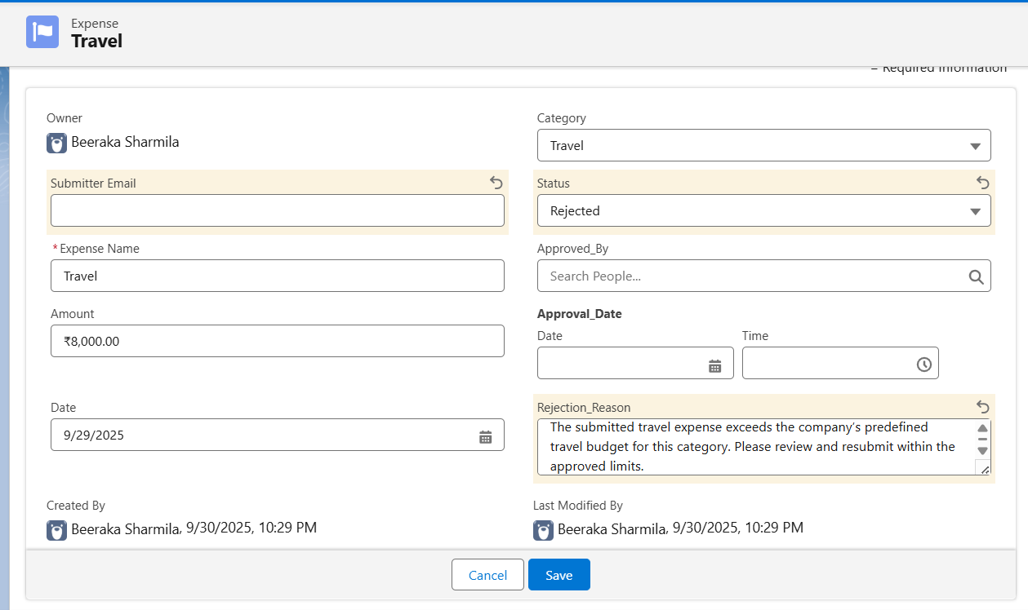
- Email Notifications
  - An Apex trigger sends automatic email notifications to the submitter when an expense is approved or rejected.
  - Email contains Expense Name, Amount, and Status.
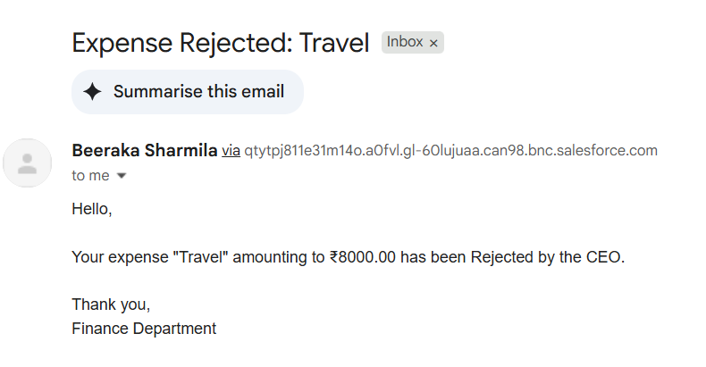
- Reporting and Dashboards
  - Reports summarize expenses by Category and Status with Amount totals.
  - Dashboards provide visual summaries using charts for management insights.
